**Evidence Digest Focus Issue: Education and Disability Inclusion**

**Easy read booklet Issue**

**Who we are**

We are Social Development Direct.

We give advice to people working on **International Development** on how to include all people, such as women and people with disabilities.

**International Development** supports people around the worldwho do not have enough access to the things they need.

We work with other groups to run the Disability Inclusion Helpdesk.

This booklet is part of the **19th Helpdesk Evidence Digest.** It focuses on education, disability inclusion and people with disabilities.

Please look at the full report for links to documents or for more information.

Sometimes we need to use new or difficult words. These words are in **bold**. There is a list of what they mean at the end of the document

**Education and Disability Inclusion**

We spoke to Dr. Grace Jamila Bila, an expert who has worked on disability inclusive education in Nigeria for 30 years.

She says that there is a shortage of teachers who are trained to support people with disabilities.

There is still **stigma and discrimination** against people with disabilities. Many children with disabilities are excluded from school.

Another problem is the lack of information on how many children with disabilities are in school.

Financial barriers also play a role. Since education is seen as expensive parents may prioritize schooling for children without disabilities.

She said there have been some very positive developments in Nigeria – policy development and **capacity building** work has been carried out and a move to include communities, parents and teachers in improving **inclusive education**.

Donors are showing commitment to **disability inclusive education** through programmes such as PLANE – the Partnership for All in Nigeria Education.

But further technical and financial support from donors is needed.

**The latest evidence and guidance on disability inclusion and education**

Lots of organizations have recently released important resources to support inclusive education.

* December 2024 – International Finance Corporation (IFC) Guide
* November 2024 – Inter-Agency Network for Education in Emergencies Webinar
* December 2024 – ReliefWeb News on Ukraine
* August 2024 – Global Education Cluster Checklist

These resources offer valuable guidance for making education more accessible for all.

Many reports and programmes in 2024 show ways we can improve educations for children with disabilities.

**Programme Learning**

July 2024 – UNICEF Report on Inclusion in Education

* Strong teamwork between different sectors
* Good partnerships and accountability
* Digital tools and community involvement
* Monitoring progress and sharing knowledge

January 2024 – Inclusive Education Initiative Report

* + Strengthening schools and teacher training
  + Improving policies to make education more inclusive.

They also highlighted some of the challenges

* November 2024 – World Bank Report on Inclusive School Infrastructure
* Lack of separate and accessible bathrooms
* Long travel distances to schools
* Insufficient facilities for students with disabilities.

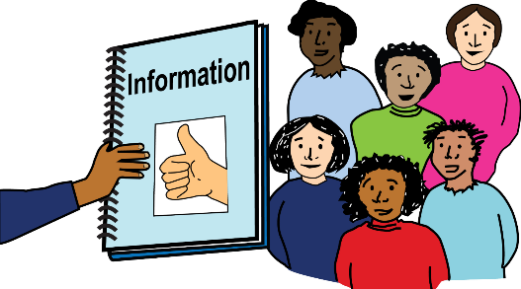

* December 2023 – A group called Humanity & Inclusion wrote a report about how to collect information on students with disabilities during emergencies.
* October 2024 – Sightsavers looked at how Sierra Leone keeps track of students with disabilities in its school system.
* December 2024 – UNICEF looked at how children are doing in 12 countries in Latin America and the Caribbean. They included information about children with disabilities in schools.
* May 2024 – A website called ResearchGate talked about the problems that poorer countries face when trying to include all children in school.
* May 2024 – In India, a study showed that workshops helped young people with autism learn to be kind online and stay safe on the internet.

**Research**

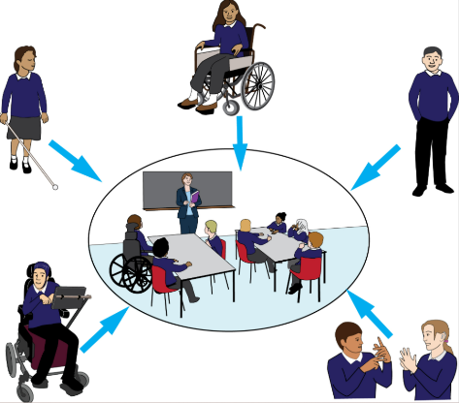

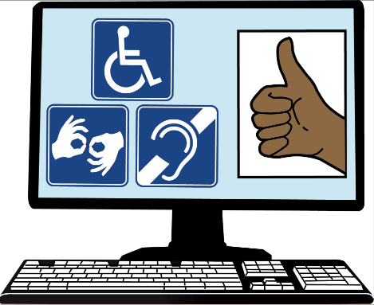

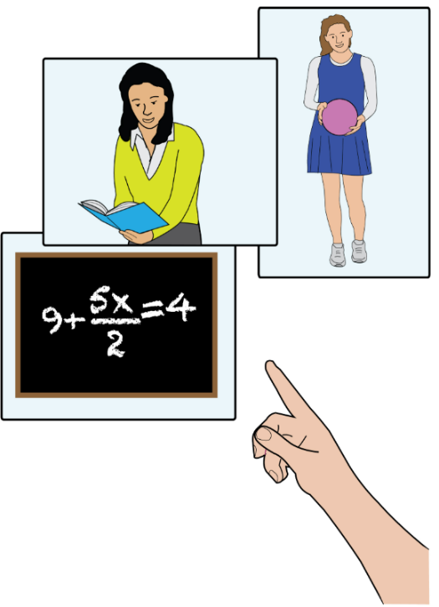

* September 2024 – A study in Colombia looked at how gym teachers help students with autism.
* December 2024 – A study showed that students who can't see well learn better with special tools and lessons that use many senses.
* October 2024 – In Malaysia, a study showed that using pictures and technology in lessons helps students with intellectual disabilities.
* November 2024 – In Indonesia, using "mind maps" in science class helped students with special needs learn better.
* December 2024 – A study in India showed that teachers who feel confident are more positive about teaching students with disabilities.

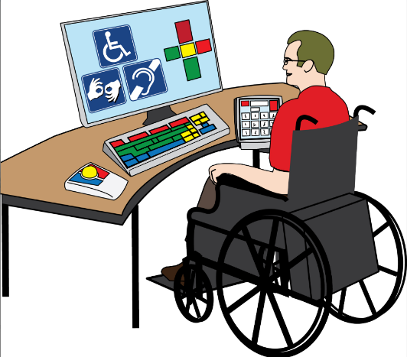

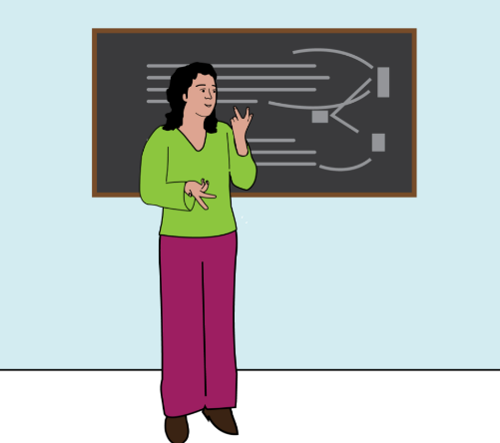

* October 2024 – A study in Afghanistan said young people who are deaf or hard of hearing need better education.
* June 2024 – A program in Colombia helped find learning and development problems early in preschool children. Helping early made it easier to include these children in school and protect their rights.
* March 2024 – A worldwide study looked at a teaching method called Universal Design for Learning (UDL). It found not much proof it’s used in poorer countries and suggested better rules are needed.
* March 2024 – A group called the Inclusive Education Initiative shared ideas on how to use technology to support students with disabilities. They gave advice to people who make education rules.

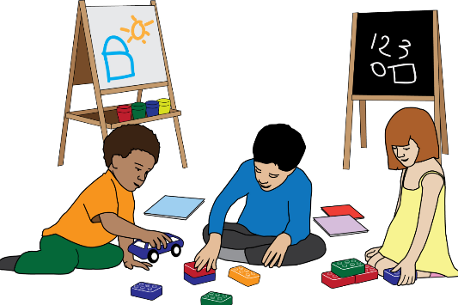

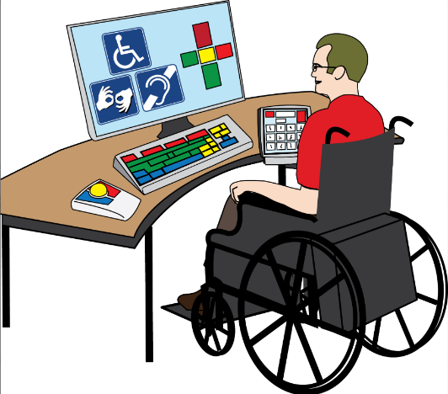

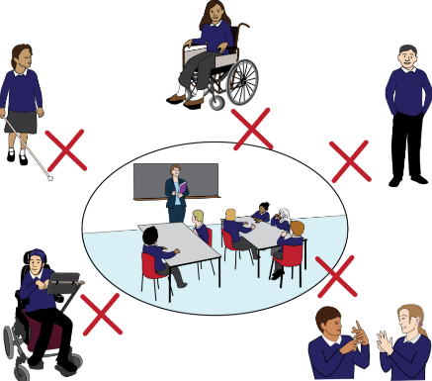

* May 2024 – A study in eight African countries showed that children with learning and multiple disabilities have the hardest time getting into and staying in school.
* May 2024 – In Nepal, a study found that the country’s education rules sometimes mix medical views and human rights ideas in ways that don’t always match.
* March 2024 – The Inclusive Education Initiative gave advice on how to use technology to help students with disabilities and shared tips for people who make education policies.

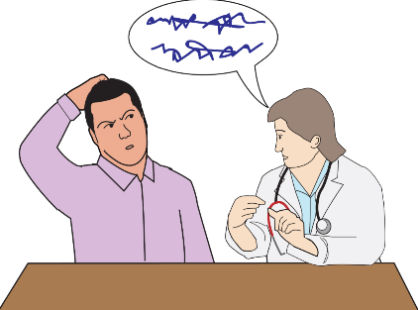

* October 2024 – A study in Zimbabwe showed that teachers find it hard to teach students with autism because of things like changes in routine and managing time.
* January 2024 – In Nigeria, a study found that culture and problems in the system make it hard for children with autism to get the help they need.
* October 2024 – In Bangladesh, a study found that children with disabilities are often treated unfairly and schools are not easy for them to access, but support from parents makes a big difference.
* September 2024 – In Kenya, a study found that students with and without disabilities felt their teachers were kind and helpful.
* September 2024 – A study in South Africa showed that math teachers use tools like Braille and talking calculators to help students who can’t see well, but they don’t always have enough time or resources.

## **The latest evidence and guidance on disability inclusion: Other topics**



#### **Employment**

In November 2024, UNDP Kyrgyzstan created the “Guidelines on Disability-Inclusive Employment.”.

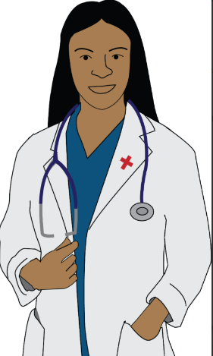

#### **Health**

In November 2024, Sightsavers studied **trachoma** in Cameroon’s East, North, Far North, and Adamaoua regions from 2016 to 2022.

In October 2024, BMC Infectious Diseases published a study on **onchocerciasis** in Ghana’s Wenchi district.

#### **Political participation**



October 2024 – A study in the African Journal of Disability looked at voting in cities in Cameroon and Senegal. It showed that there are social and environmental problems stopping people with disabilities from voting equally, and these barriers need to be removed.

October 2024 – UNICEF released a report called "In Focus: Levelling the Playing Field for Children with Disabilities (Europe and Central Asia)."

* The report says that more children with disabilities are now in schools and communities. But many still face unfair treatment. A big problem is people’s negative attitudes, and more needs to be done to help all children with disabilities take part in society.

#### **Social inclusion**

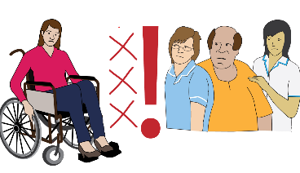

#### **Humanitarian response**

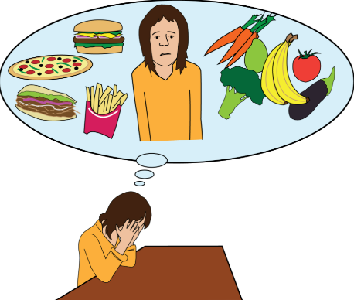

In 2024, Humanity and Inclusion wrote a report called "The Impact of War: Malnourishment and Disability in the Gaza Strip."

* The report says the war in Gaza is making life harder for people with disabilities. Many can’t escape the attacks or get the help they need.
* When Israel told people to leave northern Gaza on October 13, 2023, Many people with disabilities couldn’t leave and were left in danger. Many children have become disabled because of the fighting.

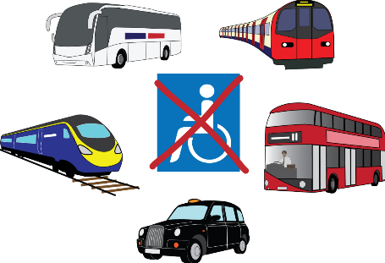

In August 2024, a report called "Women with Disabilities and Climate Change" was published. It says people with disabilities are hurt more by climate change, especially if they are poor or treated unfairly.

Women with disabilities have even more problems because of both being women and having a disability.

* They often can’t get the help, healthcare, or money they need.
* They are left out of important decisions and have fewer job chances.
* There aren’t enough rules or support to protect them during climate disasters.

The report says we must include women with disabilities in planning for climate change and meet their needs to make life fairer for all and to build and stronger future for everyone.

#### **Climate Change**

#### **Disability inclusion policy development news**

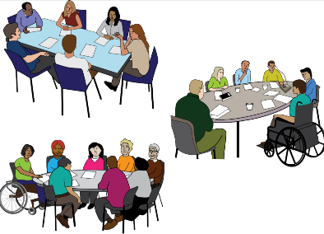

* September 2024 – Chile changed its job laws. Companies must hire at least 2% of workers with disabilities or pay a fine. They must also make workplaces accessible and safe.
* March 2024 – 17 Latin American countries agreed to track how students with disabilities are doing in school and help teachers support them using digital tools.
* May 2024 – A group in Europe asked for better protection of people with disabilities during war. They want governments and the UN to make sure people with disabilities are safe and included in emergency plans.

* July 2024 – Leaders met in Ethiopia to talk about girls’ and women’s education. They agreed on 10 ways to help. They said all girls, including those with disabilities, should be able to go to school and learn.
* June 2024 – The African Disability Protocol (ADP) started. It helps African countries make fairer laws for people with disabilities and supports their rights to live in the community.
* In 2024, some African countries made new disability laws. Kenya made laws about sign language and school support. Malawi passed a new law called the Persons with Disabilities Act in April.
* November 2024 – Australia made a new plan to include people with disabilities in climate and aid programs. They gave $12 million to help with assistive technology and want 70% of their programs to include disability by 2030.

**What do these words mean?**

**International Development**

Supports people around the world who do not have enough access to the things they need.

**Stigma and Discrimination**

Stigma means having bad or unfair thoughts about someone just because they are different. Discrimination means treating someone unfairly because of who they are.

**Capacity Building**

Capacity building means helping people, groups, or communities get better at what they do.

**Inclusive Education**

Inclusive education means everyone learns together in the same school and classroom, no matter their ability, background, or needs.

A group of people around a globe

, Picture



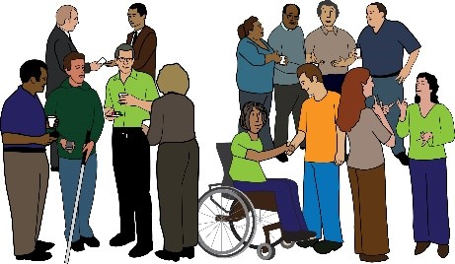

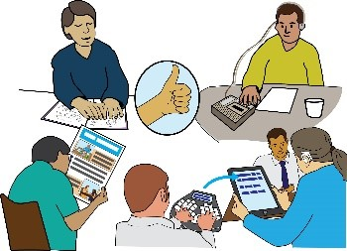

**Contact us**

Picture 4206, Picture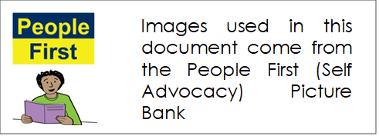

If you want to talk to us send an email to this address **enquiries@disabilityinclusion.org.uk**

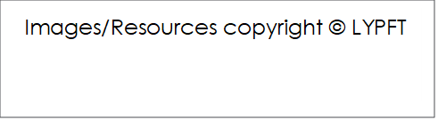

, Picture

The full version of this document is called **Evidence Digest: Social Protection and Disability Inclusion**